

**Diko** Admin Guide

v1.0

©2017-2019 版權所有坐言起行教育有限公司。

**目录**

1 系統功能 4

1.1 SYSTEM CONFIGURATIONS 4

1.1.1 System Email Setting 4

1.1.2 System Email Message 5

1.1.3 General Setting 6

1.1.4 Watermark Setting 7

1.1.5 Capture Email Setting 8

1.1.6 User Group Management 9

1.1.7 Add New User 10日

1.1.8 Modify User 12

1.1.9 Delete User 14

1.1.10 Reset Password 15

1.1.11 Add New Group 16

1.1.12 Modify Group 17

1.1.13 Delete Group 18

1.1.14 Add User into Group 18

1.1.14.1 Drag and drop user 18

1.1.14.2 Add User from another groups 19

1.1.15 Transfer Ownership 19

1.2 DEFINE CATEGORIES AND ATTRIBUTES 21

1.2.1 Add Category 22

1.2.2 Modify Category 25

1.2.3 Delete Category 25

1.3 NEWS PUBLISHING 25

1.3.1 Add News 26

1.3.2 Modify News 27

1.3.3 Delete News 29

1.4 ROLE MANAGEMENT 29

1.4.1 Add Role 30

1.4.2 Delete Role 32

1.5 DOCUMENT STATUS SUMMARY 32

1.5.1 Document Status Summary 33

1.5.2 Document Index 34

1.5.3 PDF Rendition 35

1.6 REPORTING 36

1.6.1 Audit Trail Report 36

1.6.2 User / Group Report 37

1.6.3 User Access Report 38

1.6.4 Folder Summary Report 39

1.6.5 Shortcut Report 40

1.6.6 Permission Different Report 41

1.6.7 Master Folder Object Summary 41

1.6.8 Master Folder Permission Summary 42

1.7 ADMIN CHECK IN 42

1.8 IMMEDIATE ARCHIVE 43

2 附錄 44

2.1 CONTACT 44

# 系統功能

This section describes system function of the **Diko** Server.

## System Configurations

### System Email Setting

Enter the SMTP Server information to access send email function in **Diko**.

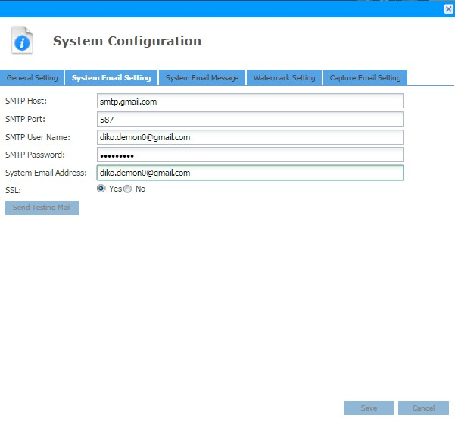

### System Email Message

This tab is to customize the email message.

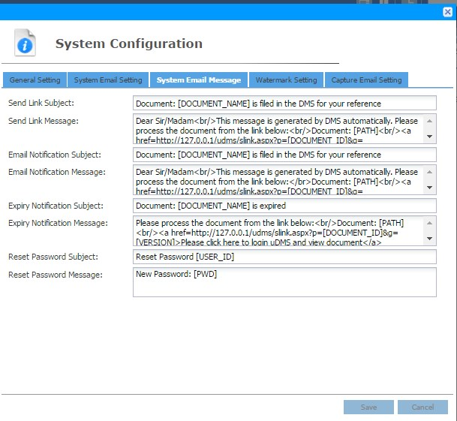

### General Setting

To configure ***General Setting***, click the  button on the **Menu** section and click the ***System Configuration*** function > ***General Setting*** tab.

The **General Setting** screen will be shown as follows:

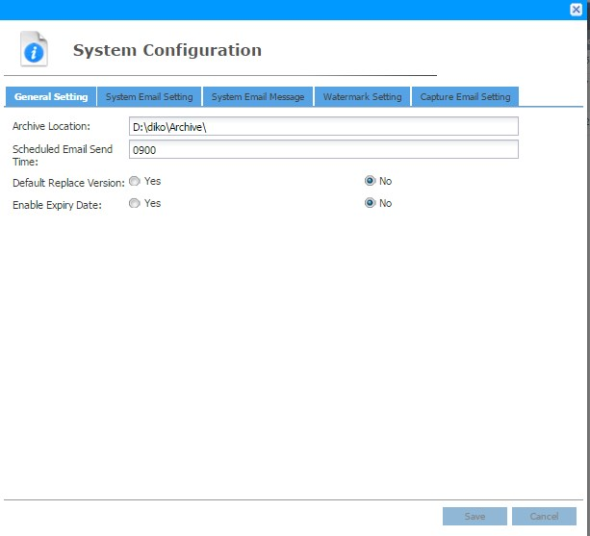

Customize the setting and then click the button to save this setting. To cancel saving configuration, click the button to exit the **System Configuration** screen.



| Field | Description |
| --- | --- |
| Archive Location | The export location of ***Immediate Archive*** function. |
| Scheduled Email Send Time | Specify when to send out the email. |
| Default Replace Version | Auto-selected replace version or not when function ‘New  Version’ and ‘Check In with new version’ |
| Enable Expiry Date | Specify whether enable expiry date of document |

**Table 1 General Setting**

### Watermark Setting

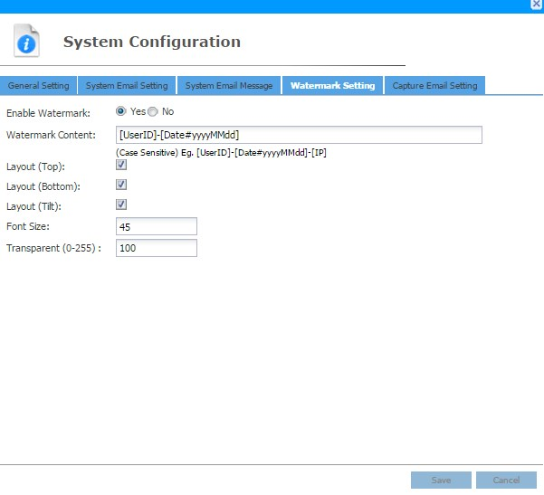

Watermark content shows the following content.



Font size will be size of the watermark content.

Customize the watermark setting and then click the button to save this setting.



To cancel saving configuration, click the button to exit the **System**

**Configuration** screen

### Capture Email Setting

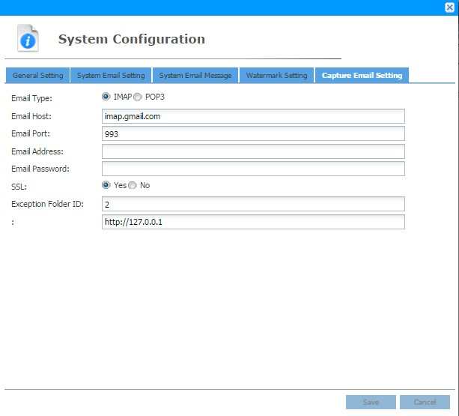

### User Group Management

To add new User or User Group in **Diko**, click the  button on the **Menu** section and click the ***User Group Management*** function. There are 5 default user groups namely “**System Admin**”, “**Project Folder Creation**”, “**Project Template Maintenance**”, ”**Checkout Document Maintenance**” ,"**Document Category Maintenance**" and they cannot be deleted.

* **System Admin**

User in this group has the right to access the System functions in Diko.

* **Project Folder Creation**

Users in this group have the right to use the template to create folder.

* **Project Template Maintenance**

Users in this group are able to create the template folder under Projects Template.

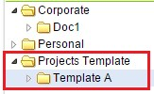

* **Checkout Document Maintenance**

Users in this group are able to check-in other check-out document.

The **User Group Management** screen will be shown as follow:

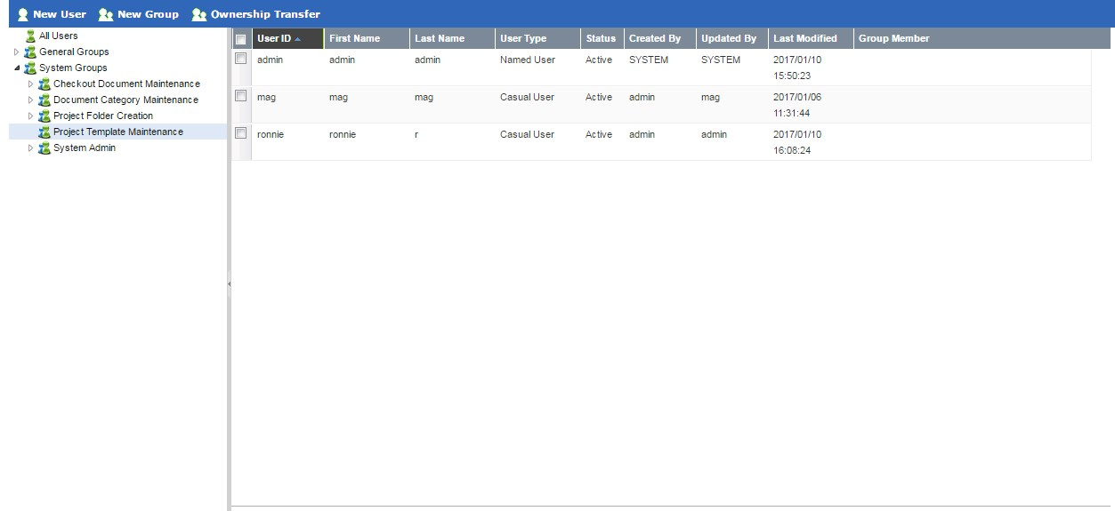

The left panel lists the **User** and **User Group**. The right panel lists the users or user groups which belong to the selected **User** or **User Group** on the left panel.

### Add New User

To add a new user, click the  button and the **New User** screen will be shown:

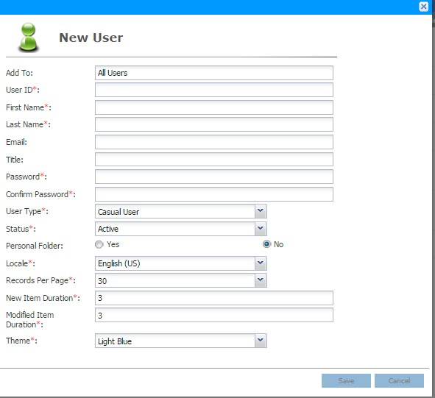

Entering the values for the fields marked with a red (*) and click the button to create the user. Click the  button to exit the screen.

The following table describes the fields in the **New User** screen.

|  |  |
| --- | --- |
| Field | Description |
| Add To | The **User Group** which the user belongs to. Click on the  group from the tree panel and then click, this field will show the selected group name. |
| User ID | The unique Login ID for the user. |
| First Name | The first name of the user. |
| Last Name | The last name of the user. |
| Email | The email address of the user. |
| Title | The title of the user. This can be blanked. |
| Password | The password for the user. |
| Confirm Password | Re-type the password for the user. |
| User Type | The type of the user. Name user or Casual User |
| Status | The status of the user. “**Active**” enables the user to logon to the system. “**Disable**” suspends the user to access the system. |
| Personal Folder | To enable or disable personal/private **Diko** folder. Default is set to **Yes**. |
| Locale | The language for the User Interface. It can be “**English**”,  “**Japanese**”, “**Simplified Chinese**” or “**Traditional Chinese**”. |
| Records Per Page | The number of records shown on each page. The value ranges from **10** to **60**. |
| New Item Duration | Specify the number of days to classify the Object as “New”.  An icon  indicates the Object is newly created. |
| Modified Item Duration | Specify the number of days to classify the Object as “Modified”. An icon  indicates the Object is modified. |
| Theme | The color theme used for the User Interface. It can be “**Evergreen**”, “**Light Blue**” , “**Dark Metal**”, "**Dark Red**","**Dark Blue**" or "**Dark Green**". |

**Table 2 New User fields description**

### Modify User

To modify the user properties, right mouse-click the User to bring up the pop-up menu

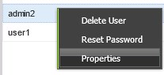

Click the ***Properties*** function. The **User Profile** screen will be shown:

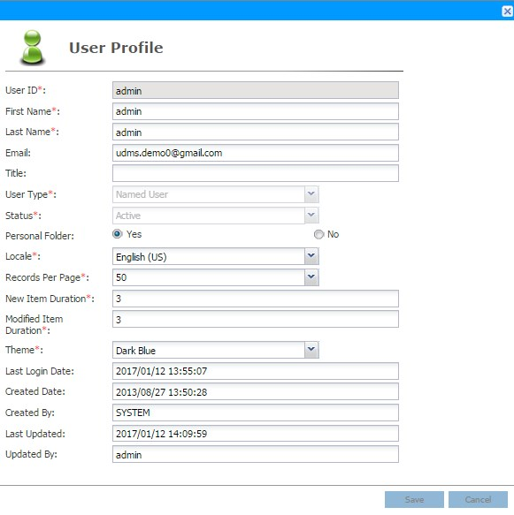

Once the modification is made, click the button to save the changes. Click the

 button to exit the screen.

The following table describes the fields in the **User Profile** screen.

|  |  |
| --- | --- |
| Field | Description |
| User ID | The unique Login ID for the user. |
| First Name | The first name of the user. |
| Last Name | The last name of the user. |
| Email | The email address of the user. |
| Title | The title of the user. This can be blanked. |
| User Type | The type of the user. Name user or Casual User |
| Status | The status of the user. “**Active**” enables the user to logon to the system. “**Disable**” suspends the user to access the system. |
| Personal Folder | To enable or disable personal/private Diko folder. It loads the previous setting of that user. |
| Locale | The language for the User Interface. It can be “**English**”,  “**Japanese**”, “**Simplified Chinese**” or “**Traditional Chinese**”. |
| Records Per Page | The number of records shown on each page. The value ranges from **10** to **60**. |
| New Item Duration | Specify the number of days to classify the Object as “New”.  An icon  indicates the Object is newly created. |
| Modified Item Duration | Specify the number of days to classify the Object as “Modified”. An icon  indicates the Object is modified. |
| Theme | The color theme used for the User Interface. It can be “**Evergreen**”, “**Light Blue**” , “**Dark Metal**”, "**Dark Red**","**Dark Blue**" or "**Dark Green**". |
| Last Login Date | The date and time when the user lastly accessing the system. |
| Created Date | The date and time when the user was created |
| Created By | The user who created this user profile. |
| Last Updated | The date and time when the user profile was modified. |
| Updated By | The user who updated this user profile. |

**Table 3 User Profile fields description**

### Delete User

To delete a user, right mouse-click the User to bring up the pop-up menu

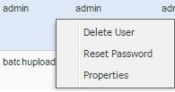

Click the ***Delete User*** function. A confirmation message will prompt the user to confirm the deletion of the user.

to delete the user or click the  to cancel the deletion.

Click the

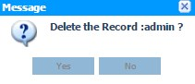

### Reset Password

To reset password of a specific user, right mouse-click the User to bring up the pop-up menu



Click ***Reset Password*** function, an interface will be promoted.

Click the button to reset. Click the following table describes the fields in the **Reset Password** screen.

button to exit the screen. The

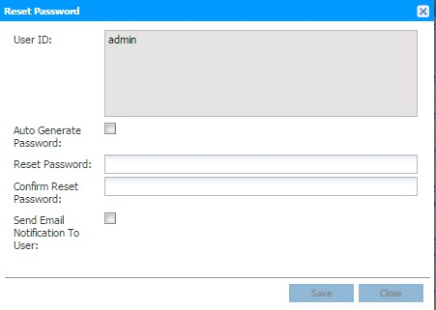

|  |  |
| --- | --- |
| Field | Description |
| User ID | The user which is currently selected. |
| Auto Generate Password | Auto generates a password and sends to this user via email. |
| Reset Password | Customize a password for this user. |
| Confirm Reset Password | Re-enter the password. |
| Send Email Notification  To User | Specify whether to send email to this user. |

**Table 4 Reset Password field description**

### Add New Group

To add a new user group, click the  button and the **New Group** screen will be shown:

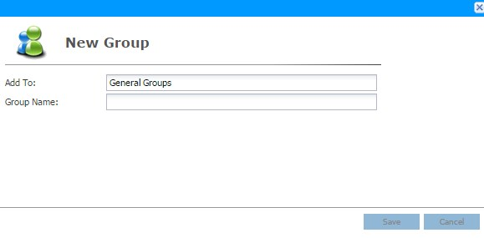

Entering the value for the “**Group Name**” field and click the button to create the user group. Click the  button to exit the screen.

The following table describes the fields in the **New Group** screen.

|  |  |
| --- | --- |
| Field | Description |
| Add To | The **User Group** which the user group belongs to. |
| Group Name | The unique new user group name. |

**Table 5 New Group fields description**

### Modify Group

To modify the user group properties, right mouse-click the User to bring up the pop-up menu and click the ***Properties*** function. The **Group Properties** screen will be shown:

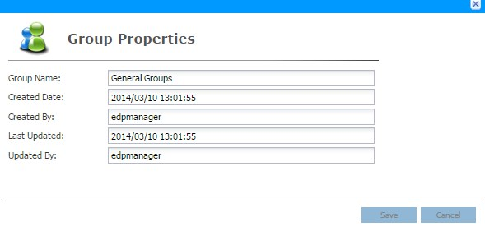

Once the modification is made, click the button to save the changes. Click the

 button to exit the screen.

The following table describes the fields in the **Group Properties** screen.

|  |  |
| --- | --- |
| Field | Description |
| Group Name | The unique name of the user group. |
| Created Date | The date and time when the user group was created |
| Created By | The user who created this user group. |
| Last Updated | The date and time when the user group was modified. |
| Updated By | The user who updated this user group. |

**Table 6 Group Properties fields description**

### Delete Group

To delete a user group, right mouse-click the User to bring up the pop-up menu

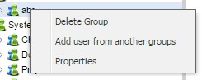

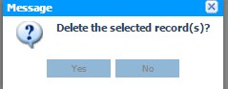

Click the ***Delete Group*** function. A confirmation message will prompt the user confirm the deletion of the user group.

Click the  to delete the user group or click the  to cancel the deletion.

### Add User into Group

#### Drag and drop user

To add user into a group, click ‘All Users’ from the left tree panel to show all users. Then **drag and drop** the user into desired group.

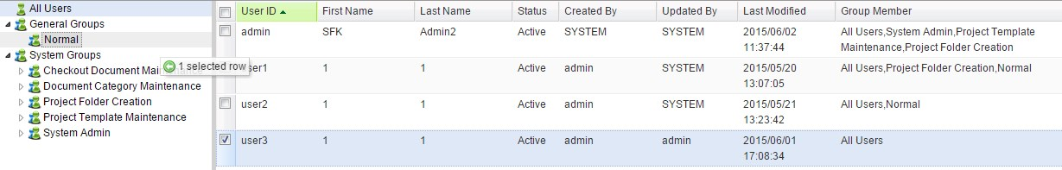

After that, the *Group Member* column will show the group just added to this user.

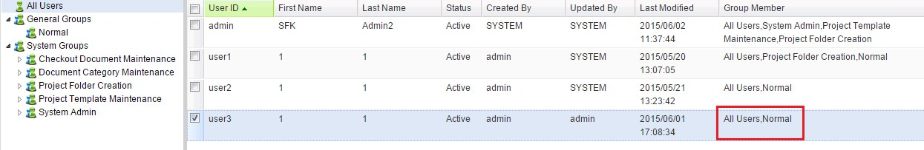

#### Add User from another groups

To add user from another groups, right click a group to bring up menu

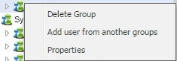

Click ***Add user from another groups*** function,

Select the group(s) that will be transferred from, click to transfer, click

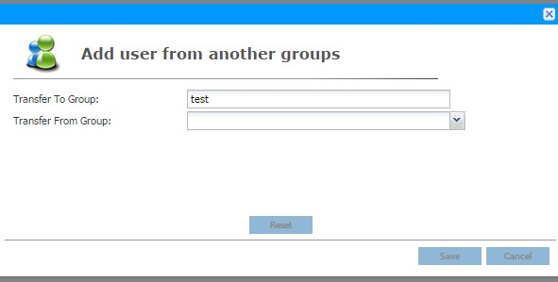

to cancel transfer.

### Transfer Ownership

To transfer ownership, click the  button and the **Ownership**

**Transfer** screen will be shown:

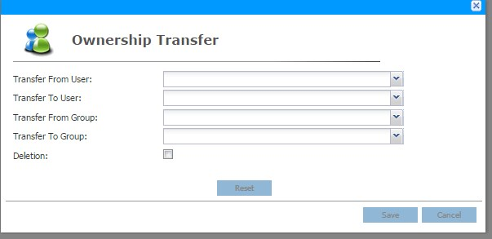

User can either **transfer from user to user** OR **transfer from group to group.** If ticked **Deletion**, it will delete the User/Group that is transferred from.

## Define Categories and Attributes

To define the categories of attributes, click the  button on the **Menu** section and click the ***Category Shelf*** function. The **Category Shelf** screen lists all categories and the screen is depicted as follows:

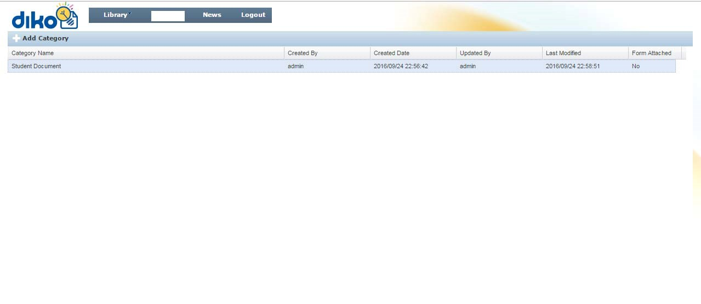

### Add Category

To add a new category, click the  button and the category setup screen is shown as follows:

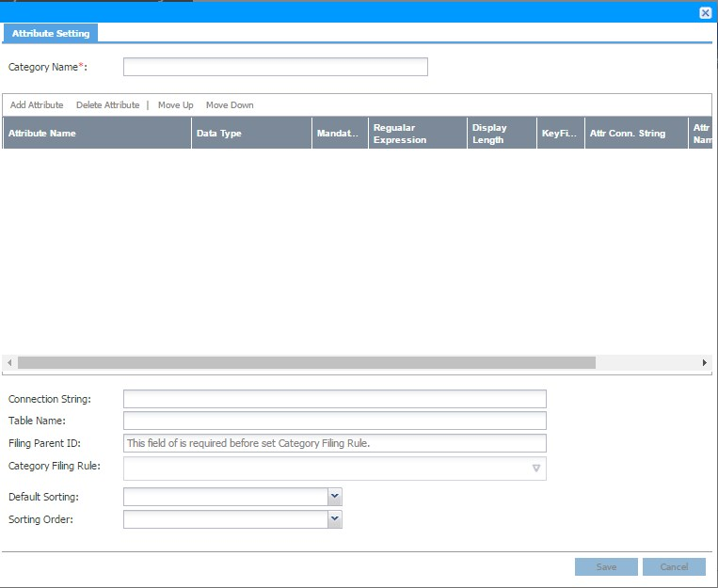

Enter the name in the “**Category Name**” field and click the  function to create attribute fields for the category.

Choose the data type:

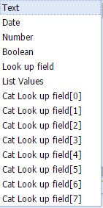

Specify properties for each attribute field. Once done, click the button to create the category or click the  to exit the screen.

The following table describes the fields in the **Category Setup** screen.

|  |  |
| --- | --- |
| Field | Description |
| Category Name | The unique name for the **Category**. |
| Attribute Name | The unique name for the **Attribute**. |
| Data Type | The data type for the **Attribute**. |
| Mandatory | Specify whether the value must be entered for the **Attribute**.  If the checkbox is ticked, a value must be entered for the field. |
| Regular Expression | Specify what value can be entered for the **Attribute**. E.g. [A-  Z] allows data to be entered must be between “A” to “Z”. [09] allows data to be entered must be a number between “0” to “9”. **This field can be** **blanked**. |
| Display Length | Indicate the display length of the column at the document display column. **(0 means no limited)**  Eg. If user set it to 2, the column will look like this: |
| Key Field | Key Field for Look-up value. |
| Attr Conn String | Connection string for Look-up value validation. |
| Attr Table Name | Table name for Look-up value validation. |
| Attr Column Num. | The column number of table for Look-up value validation. |
| Connection String | Connection String for Look-up value. |
| Table name | Table name for Look-up value. |
| Allow Change Doc.  Name | Specify whether the document name can be changed. |
| Default Sorting | Select the field that will be sorted. |
| Sorting Order | Defined the field will be sorted by **Ascending** or **Descending.** |

**Table 7 Category Setup fields description**

### Modify Category

To modify a category, right mouse-click the **Category** to bring up the pop-up menu

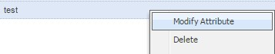

Click the ***Modify Attribute*** function. After modifying the Attribute properties, click the

 button to save the changes or click the  to exit the screen.

### Delete Category

To delete a **Category**, right mouse-click the **Category** to bring up the pop-up menu

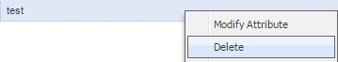

Click the ***Delete*** function to delete category.

## News Publishing

There are two types of news in **Diko** namely, Public and Private. Public news shows on the Login screen while Private news shows in **Diko** Main screen. To publish a news, click the  button on the **Menu** section and click the ***News Publishing*** function. The **News Publishing** screen lists both Public and Private news and it is depicted as follow:

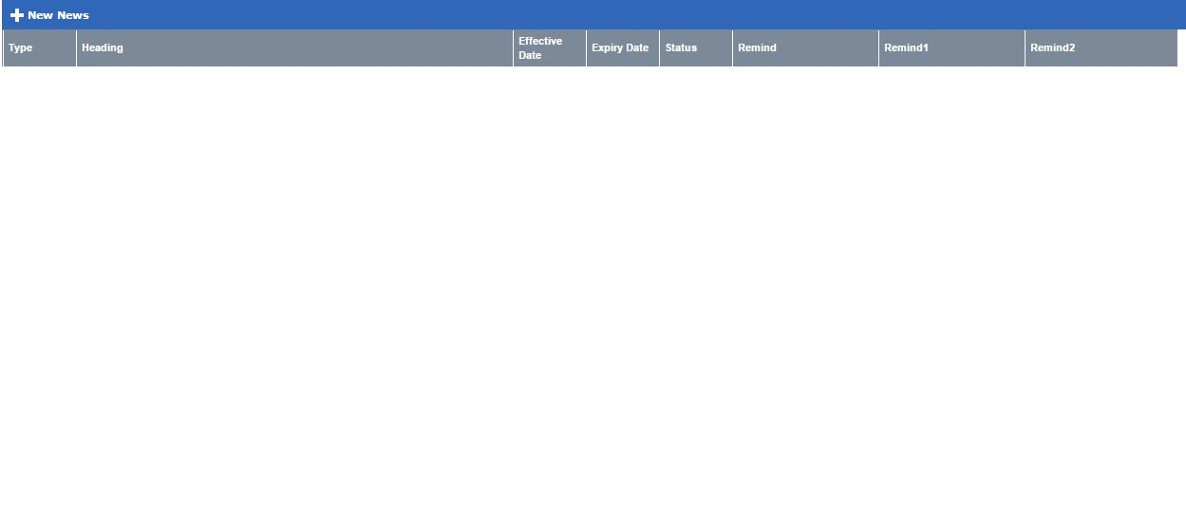

### Add News

To add new news, click the  button and the **New News** screen is shown as follow:

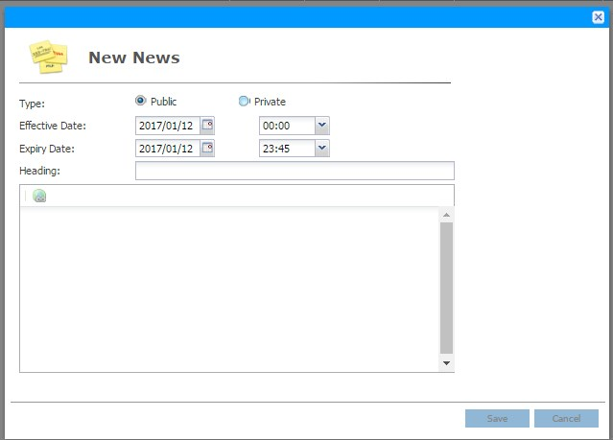

Specify the news type, choose the **Effective date/time**, **Expiry date/time** and enter the

**Heading** and **news message**, then click the to save the news or click the

 button to exit the screen. If the news is created and the effective date/time is

reached, the news will be published. If the expiry date/time is reached, the news will be taken off from the system.

The following table describes the fields in the **New News** screen.

|  |  |
| --- | --- |
| Field | Description |
| Type | Type of the news. It can be “**Public**” or “**Private**”. |
| Effective Date | The date/time when the news will be published. |
| Expiry Date | The date/time when the news will be taken off from the system. |
| Heading | The news heading. |
|  | Specify the URL for the news. |
| News Message | Specify the news message. |

**Table 8 New News Fields Description**

### Modify News

To modify a news, right mouse-click the News to bring up the pop-up menu

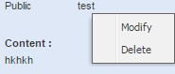

click the **Modify** function. The **News Modification** screen is shown as follow:

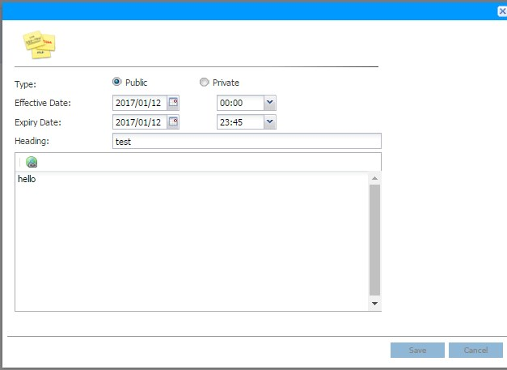

Make the changes to the news and click the to save the news or click the

 button to exit the screen. If the news is saved and the effective date/time is reached, the news will be re-activated. If the expiry date/time is reached, the news will be taken off from the system.

The following table describes the fields in the **News** **Modification** screen.

|  |  |
| --- | --- |
| Field | Description |
| Type | Type of the news. It can be “**Public**” or “**Private**”. |
| Effective Date | The date/time when the news will be published. |
| Expiry Date | The date/time when the news will be taken off from the system. |
| Heading | The news heading. |
|  | Specify the URL for the news. |
| News Message | Specify the news message. |

**Table 9 News Modification Fields Description**

### Delete News

To delete a **News**, right mouse-click the **News** to bring up the pop-up menu

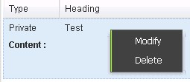

Click the ***Delete*** function. A confirmation message will prompt the user to confirm the deletion of the news.

Click the button to delete the news or click the  button to cancel the deletion.

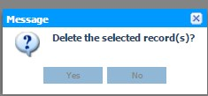

## Role Management

To modify role, click the  button on the **Menu** section and click the ***Role Management*** function. The ***Role Management*** screen lists Role list as follow:

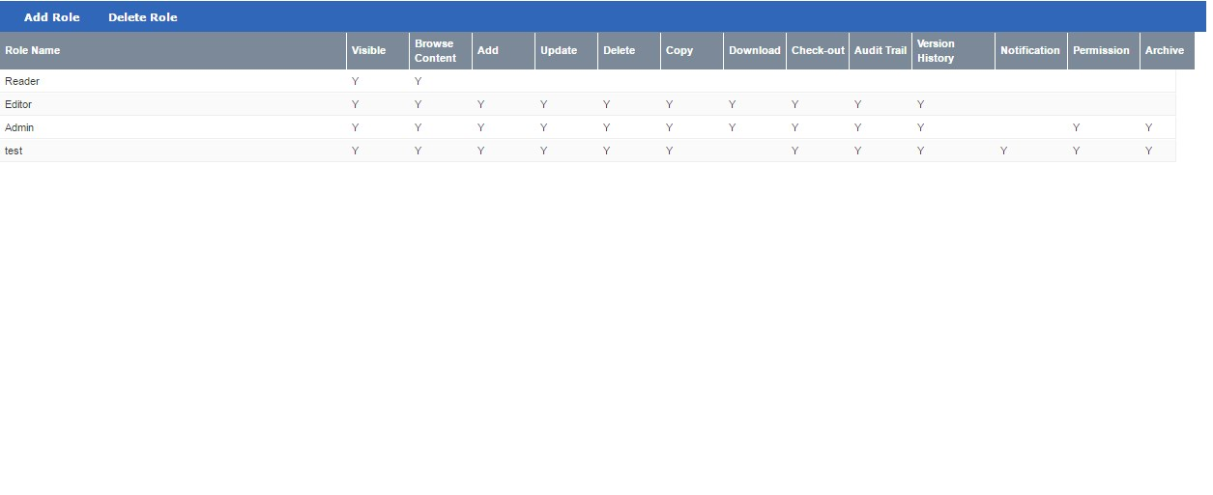

\*\*\***Reader, Editor, Admin** are system preset Roles and cannot be deleted.

### Add Role

To Add Role, click

and the following screen shows:

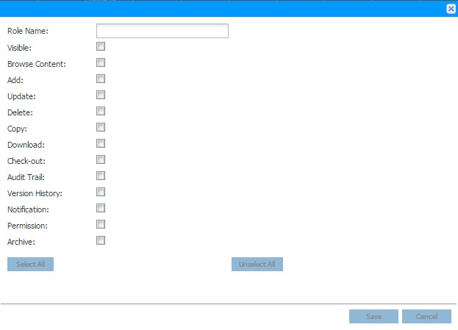

Enter the role name and check-on needed permission. Click to save this role.

Click  to exit the screen.

The following table shows the permission description:

|  |  |
| --- | --- |
| Permission | Description |
| Role Name |  |
| Visible | Status that the folder/ document are visible to the user. |
| Browse Content | Allow viewing the contents of the document. If user has no browse permission to a folder. The content of that folder will not be seen. |
| Add | Allow adding document. |
| Update | Allow the values of **Keywords, Classification, Description, Categories** and **System Fields** can be updated. |
| Delete | Allow deleting the document. |
| Copy | Allow copy, move, cut options. The target folder must have **Add** permission in order to paste into it. |
| Download | Allow downloading the document. |
| Check-out | Allow check-in/check-out of the document. If the document is checked-out, the document is locked and only allow for viewing. If the document is checked-in, the lock on the document will be released and a new version of the document may be created. |
| 审计日志 | Allow viewing the audit trail of the document. |
| Version History | Allow to view the previous versions of the document. |
| Notification | Allow notification email sent to corresponding users if changes to the document occurred. |
| Permission | Allow setting the permissions of the document. |
| Archive | Allow the document can be archived. |

**Table 10 Add Role field description**

### Delete Role

To delete Role, select on a role and click  to delete role.

## Document Status Summary

There are 3 sections in Document Status Summary. To run the summary, click the

button on the

**Menu**

section and click the

***Document Status Summary***

function.

The screen will be shown as follow:

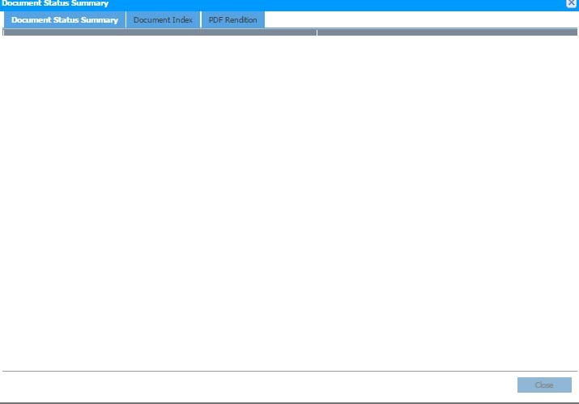

### Document Status Summary

This page is the first tab of the summary. It shows the count of Indexing status and PDF Rendition of document.

|  |  |
| --- | --- |
|  | Index Status description |
| **Status** | **Description** |
| Succeed | Documents are indexed. |
| Pending | Documents are just uploaded and waiting for indexing. |
| Failed | Documents are failed to do indexing. |
| Updated | Documents are updated to a status which is ready to do indexing. |
| In Progress | Documents are indexing. |

**Table 11 Index Status description**

|  |  |
| --- | --- |
|  | PDF Rendition description |
| **Status** | **Description** |
| Succeed | Documents are rendered |
| Pending | Documents are just uploaded and waiting for rendition. |
| Failed | Documents are failed to do rendition. |
| Unsupported | Unsupported item to do rendition. Eg. .exe file. |
| In Progress | Documents are rendering. |

**Table 12 PDF Rendition description**

### Document Index

This page allows re-indexing document with **Failed** status.

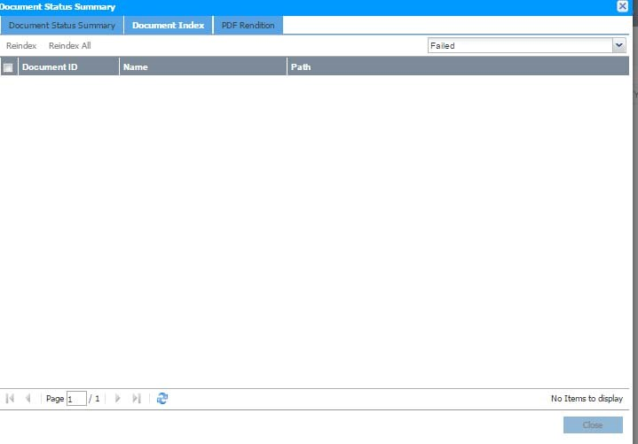

To do re-indexing, select **Failed** status through .

System will list out the failed document, click  to re-index all documents or select document and then click . User may also find other index status

documents through . System will then find the documents of the selected status for user reference.

### PDF Rendition

This page allows re-do PDF rendition for document(s) with **Failed** status.

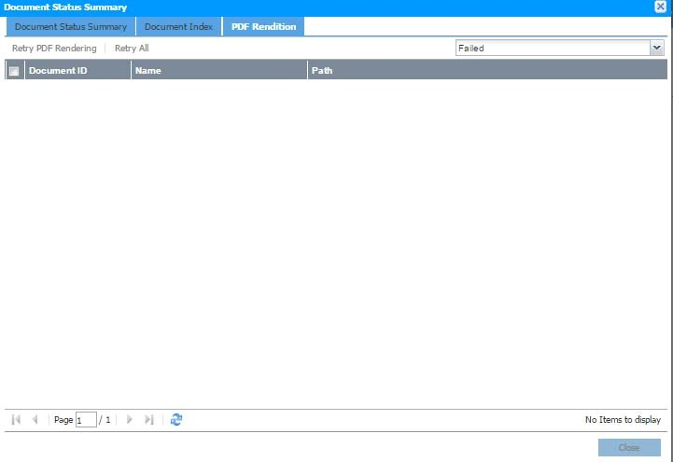

To re-do PDF rendition, select **Failed** status through .

System will list out the failed document, Click  to re-do rendition for all documents or select document and then click . User may also find

other rendered status documents through . System will then find the documents of the selected status for user reference.

## Reporting

Click the button on the **Menu** section and hover on the **Report**, click one of the report types.

There are 8 reports available in **Diko** namely

1. **Audit Trail Report**
2. **User / Group Report**
3. **User Access Report**
   1. **Full Format**
   2. **Break Down**
4. **Folder Summary Report**
5. **Shortcut Report**
   1. **Object**
   2. **Shortcut**
6. **Permission Different Report**
7. **Master Folder Object Summary**
8. **Master Folder Permission Summary**

### Audit Trail Report

To generate the Audit Trail Report, click the ***Audit Trail Report*** function and the following screen shows:

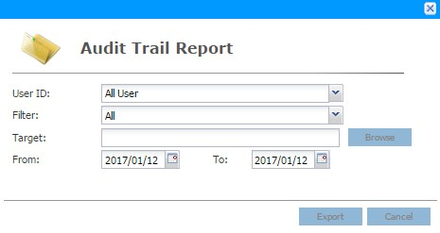

Choose the User ID through

,

Specify which activity through

,

Target location through



Activity period



Click the  button to generate the report which will be stored in the specified location as stated in the “**Target**” field. Click the  button to exit the screen.

The following table describes the fields in the **Audit Trail Report** screen.

|  |  |
| --- | --- |
| Field | Description |
| User ID | Specify which user to be listed in the report. “**All User**” means all users to be listed in the report. |
| Filter | Specify which activities to be listed in the report. “**All**” means all activities to be listed in the report. |
| Target | The location on the local workstation to store the report. |
| From | The date when the activities started. |
| To | The date when the activities ended. |

**Table 13 Audit Trail Report fields description**

### User / Group Report

To generate the User / Group Report, click the ***User / Group Report*** function and the report will be downloaded automatically.

It shows the user personal information and the group user belongs.

### User Access Report

To generate the User Access Report, click the ***User Access Report*** function and the following screen shows:

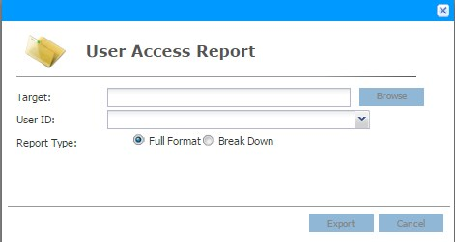

Target location through



Choose the User ID through



Choose the report type through

button to generate the report which will be stored in the specified

Click the



location as stated in the “**Target**” field. Click the  button to exit the screen.

The following table describes the fields in the **User Access Report** screen.

|  |  |
| --- | --- |
| Field | Description |
| Target | The location on the local workstation to store the report. |
| User ID | Specify which user to be listed in the report. “**All User**” means all users to be listed in the report. |
| Report Type | **Full Format** - all of the user will export into one spread sheet of excel.  **Break Down** – each user will break down into single spread sheet |

**Table 14 User Access Report field description**

Sample of the User Access Report:

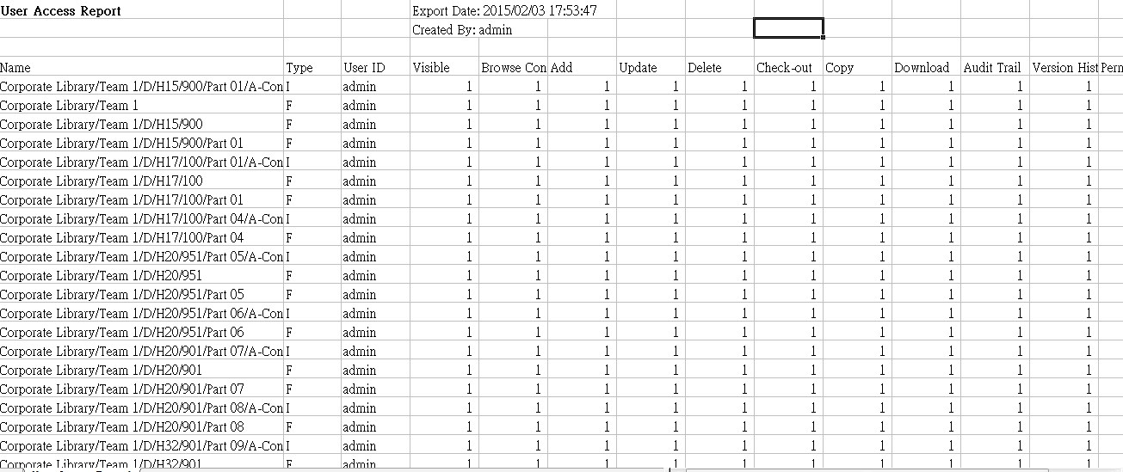

**0 means no permission of the object, 1 means have permission of the object. For the TYPE column, ‘I’ means Document, ‘F’ means Folder.**

### Folder Summary Report

To generate the Folder Summary Report, click the ***Folder Summary Report*** function and the report will be downloaded automatically.

This report is to check the number of folder and document in certain location.

### Shortcut Report

To generate shortcut report, click ***Shortcut Report*** function and the following screen will be shown:

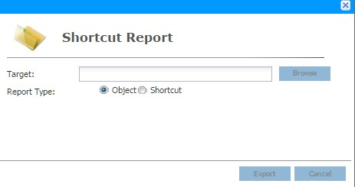

Target location through



Choose the report type through

button to generate the report which will be stored in the specified

Click the



location as stated in the “**Target**” field. Click the  button to exit the screen.

The following table describes the fields in the **Shortcut Report** screen.

|  |  |
| --- | --- |
| Field | Description |
| Target | The location on the local workstation to store the report. |
| Report Type | **Object** – It shows the related shortcut of the objects in the selected target and shows its location.  **Shortcut** – It shows the shortcuts of the selected target and what documents are referred from. |

**Table 15 Shortcut Report field description**

### Permission Different Report

To generate permission different report, click ***Permission Different Report*** function and the following screen will be shown:

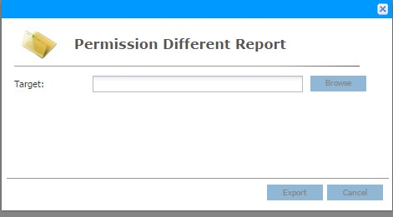

Target location through



Click the  button to generate the report which will be stored in the specified location as stated in the “**Target**” field. Click the  button to exit the screen.

It shows the permission of documents inside the selected target is different from the selected target.

### Master Folder Object Summary

To generate the Master Folder Object Summary, click the ***Master Folder Object Summary*** function and the report will be downloaded automatically.

This report is to check the number of folders, files, shortcuts inside the master folder; it also shows the master folder location.

### Master Folder Permission Summary

To generate the Master Folder Permission Summary, click the ***Master Folder Permission Summary*** function and the report will be downloaded automatically.

This report is to check the permission of the master folder.

## Admin Check In

In case user does not remember which documents have been checked-out (locked), Administrators can force check-in the documents that have been checked-out by any

users. To view all the checked-out documents, click the  button on the **Menu** section and click the ***Admin Check In*** function and the following screen will show:

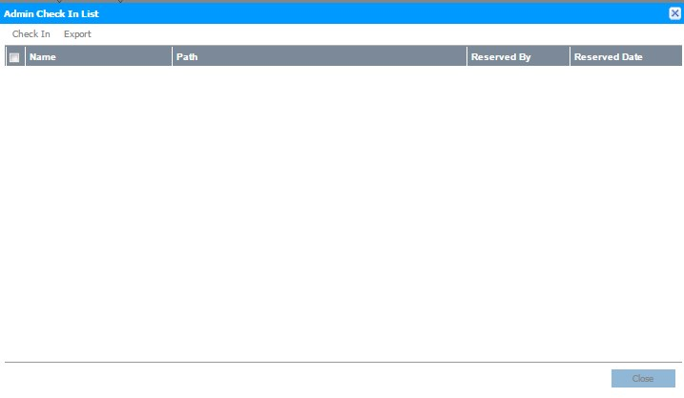

To force check in the documents, select the desired documents and click the  button. Click the  button to exit the screen.

## Immediate Archive

To archive, right click folder to bring up menu, click ***Immediate Archive***.

to keep the

Click

to remove selected files after archiving, click

related files, click

to cancel archive process.

Click

to archive the latest version, click

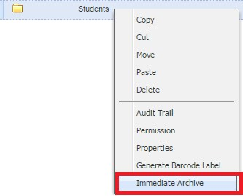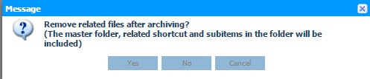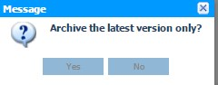

to archive ALL the versions

of the document.

The archive folder will then export to the location which is set in System Configuration

# Appendix

## 聯絡方法

Should you have any queries, please contact Speech & Act Education Company Limited (Asia) Ltd. by 3708 8303.